Cover Letter
Name: Avarile Wang
Address: 15 Seabird Dr. Point Cook, Melbourne 3030
Australia work rights: Full work rights (Permanent Resident)
Immunization status: Fully immunized
To whom concerns in “company name”:
Hi, my name is Avarile Wang, I am writing to express interests in the Frontend developer position. I have been an experienced Full stack programmer for over 6 years. Mostly worked in manufacturing fields, developing Enterprise Resource Planning and Warehousing Management system for Ford, General Motors and local marine port in Chongqing China from 2008 – 2015. Proficient with cooperating with clients / marketing or operation department, and producing robust codes based on it. Has more than 6 years of ERP / WMS developing experiences (both front end and backend).
Tech stack of C#:
ABP Framework, Furion Framework, ASP.net core, EF core, SugerSql and so on…
Tech stack consists of JavaScript / TypeScript :
Nodejs(Express.js and Nest.js along with lots of middlewares)
Reactjs ecosystems, Vue ecosystems.
Other IT related skills:
Azure, Linux, VMware, Hyper-v, Kvm, some Devops and so on…

A freshly created Demo ERP for the part-time job I did last month as a sales man:
https://avarile.github.io/dashboard/
I wrote this is because that the company I worked as a salesman is still running All their management (order / quote / fabrication / logistic … …) on Excel, so every morning when we start to work, we need to open at least 20 web pages/Excel files, that’s already a mess, when talking about to pin point a specific order or tracking an parcel about 2 weeks ago, well, that’s a disaster.

Dashboard:
Right now, without a live Backend, this is just a static page showing some mocking data.
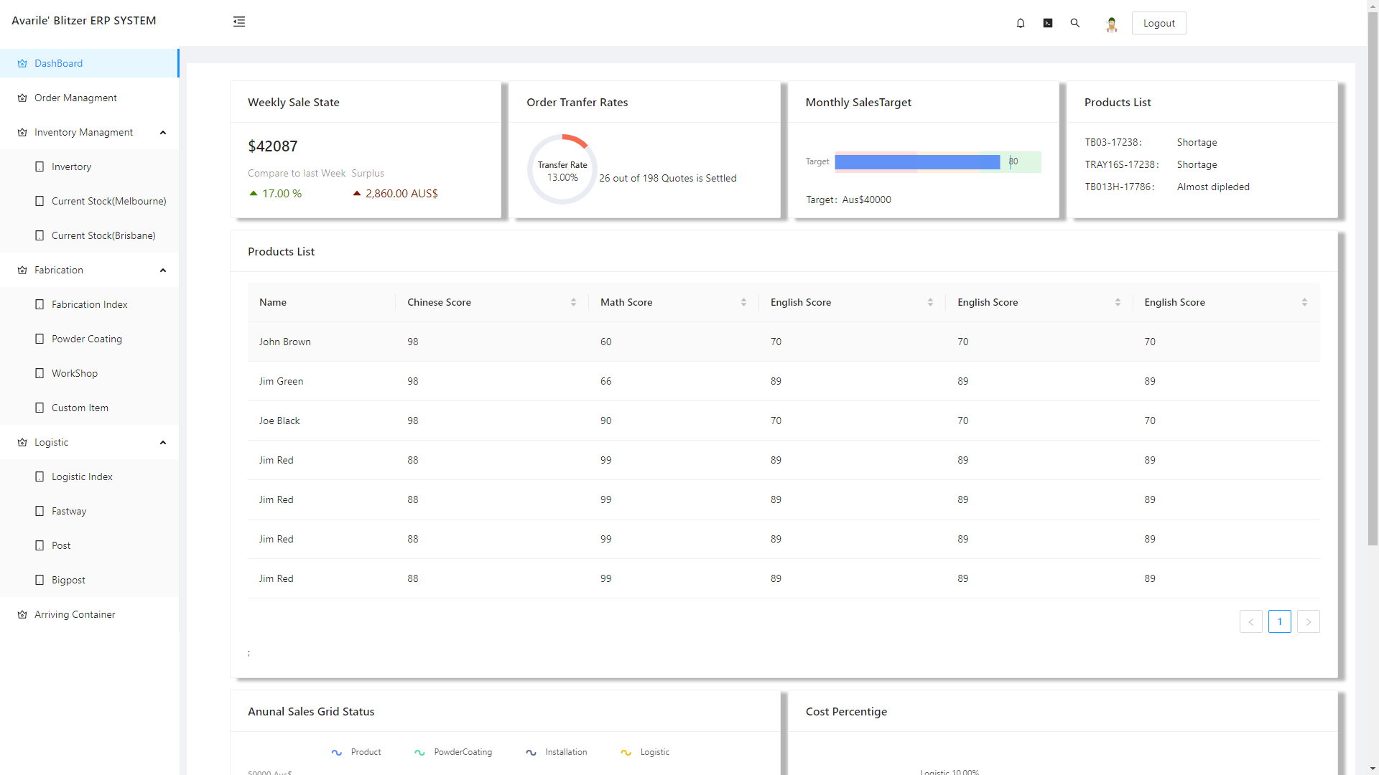

Order Management:
A filterable, detail expandable list of orders, providing all essential data about the order and it's current status --- payments, stock, price, fabrication and logistics. The salesman / operator can also add payment in this page.
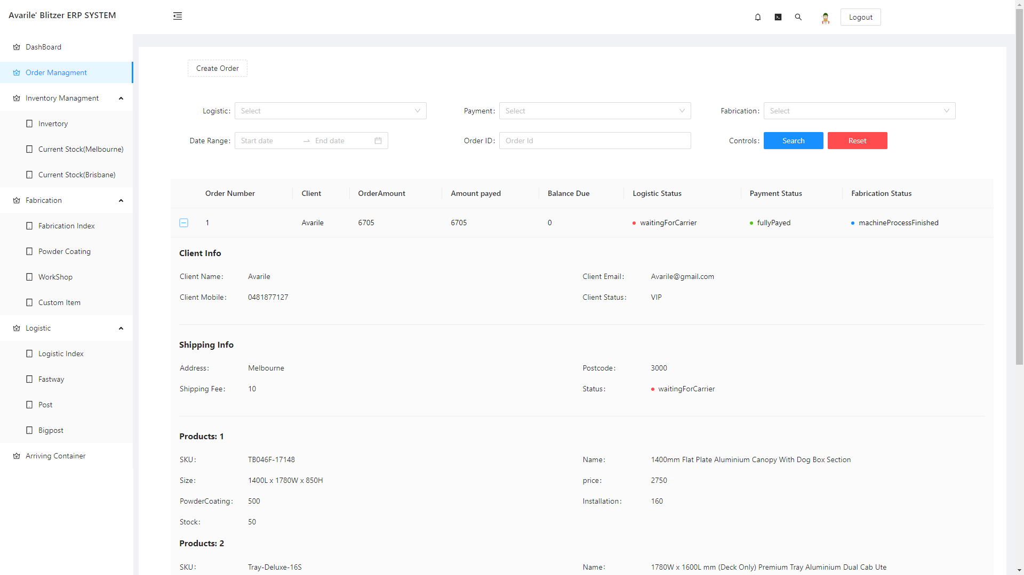
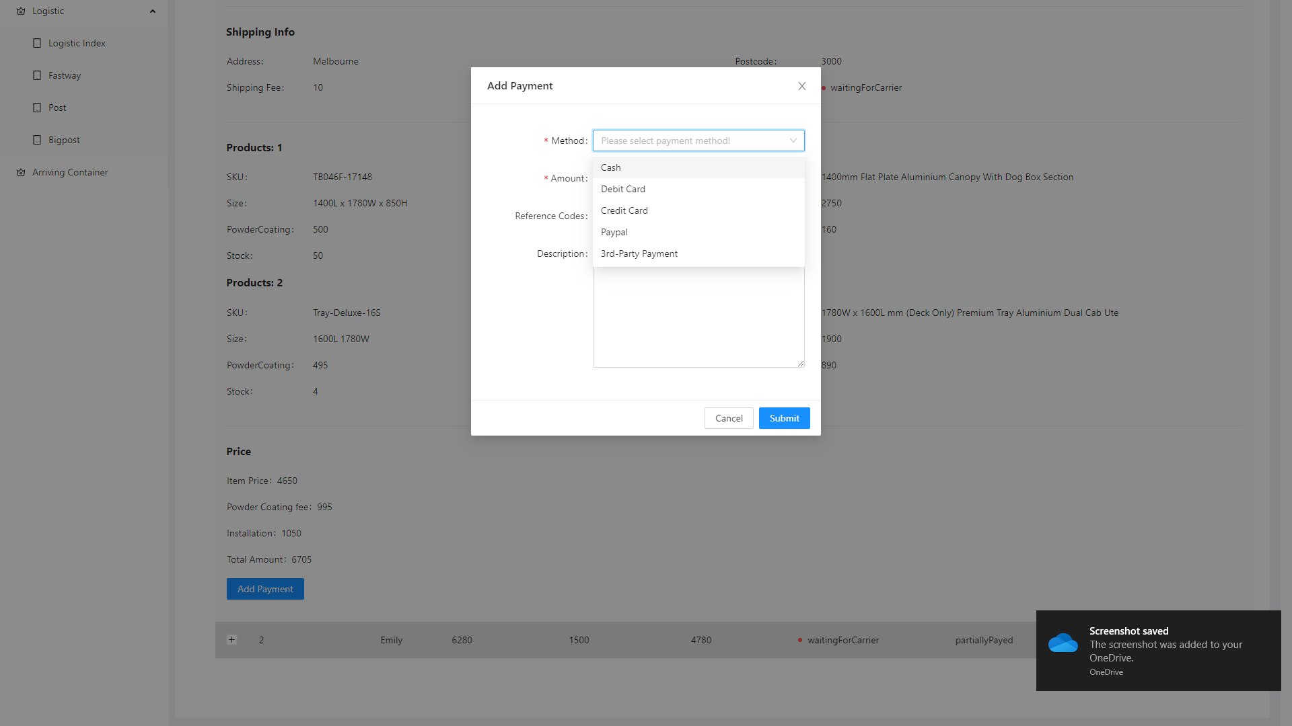

Inventory Control page:
Inventory control page consist of 3 modules, Item / Product Creation, Inbound, outbound, scrap.
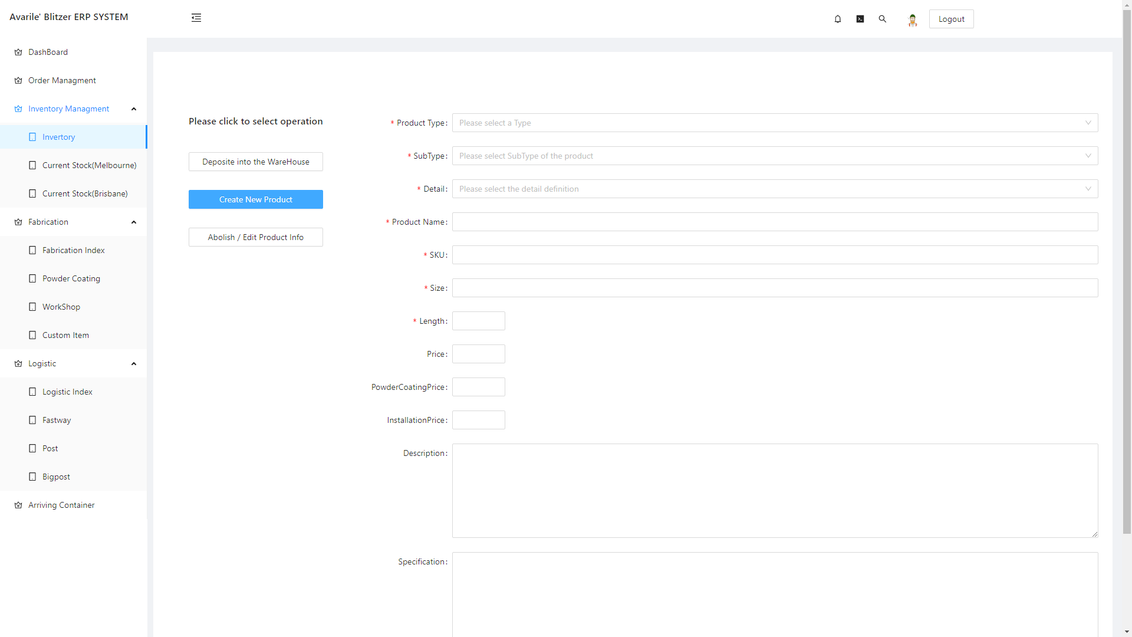

Fabrication:
Tracking fabrication related orders --- it’s a canopy / tray / toolbox company, so most of the orders involve some fabrication and powder coating job. The current order tracking system is absolutely based on Excel, if anyone forgets to put an order in the list, then this order will be completely forgotten, until the customer calls to ask… and this happens quite often.
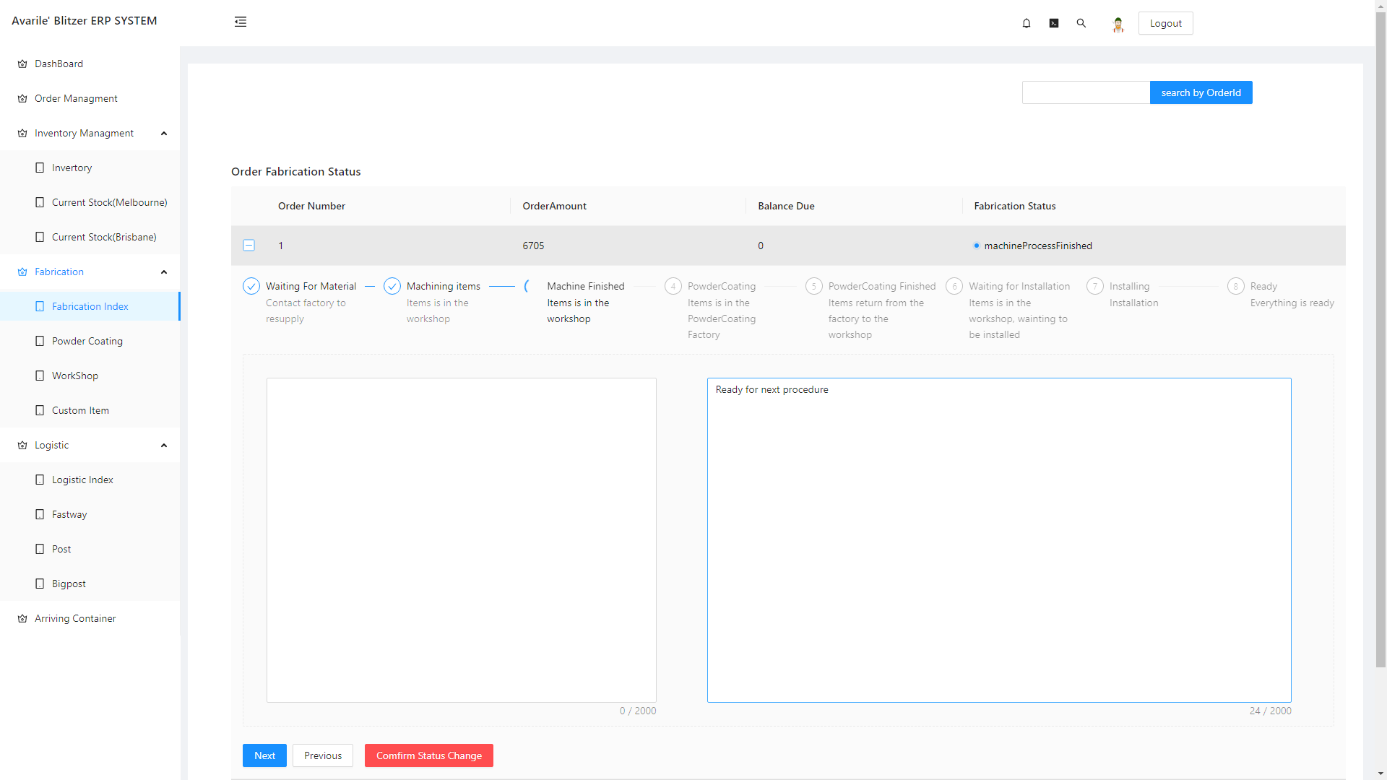

Logistic tracking:
As for everything is running on Excel, and shipping list is generating on a daily bases, without a database built for search / filter function, even if you want to find an parcel about 2 weeks ago, it will be disaster, and cost quite a lot of time.
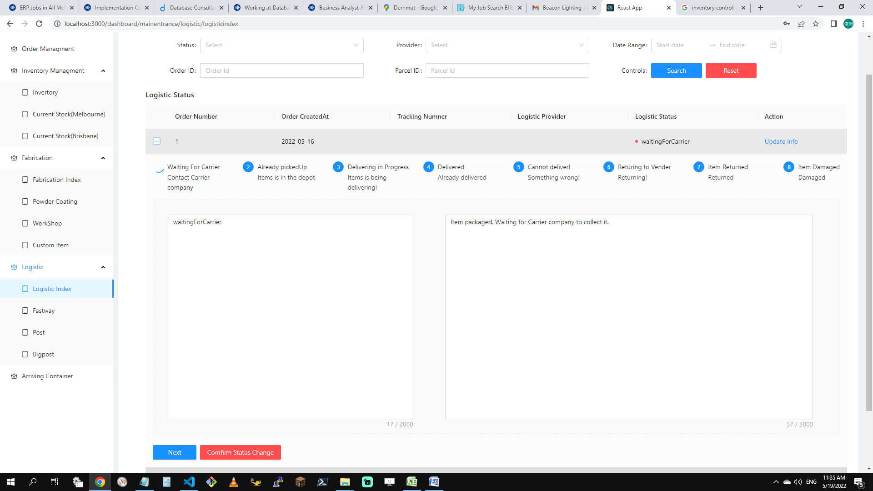

Conclusion:
This project is just a demo I created after hour, seeking to solve a real life problem, after I finish the backend, I may let the company use it for a cheap price. And it will be a portfolio site if I want to demonstrate my ability as an ERP implementation as well as a developer.

